SPRINT 2

|  |  |
| --- | --- |
| **Date** | November 13, 2022 |
| **Team ID** | PNT2022TMID07793 |
| **Project Name** | Real-Time River Water Quality  Monitoring and Control System |
| **Maximum Mark** |  |

**The following steps are involved:**

**STEP 1:** Download and Install node.js.

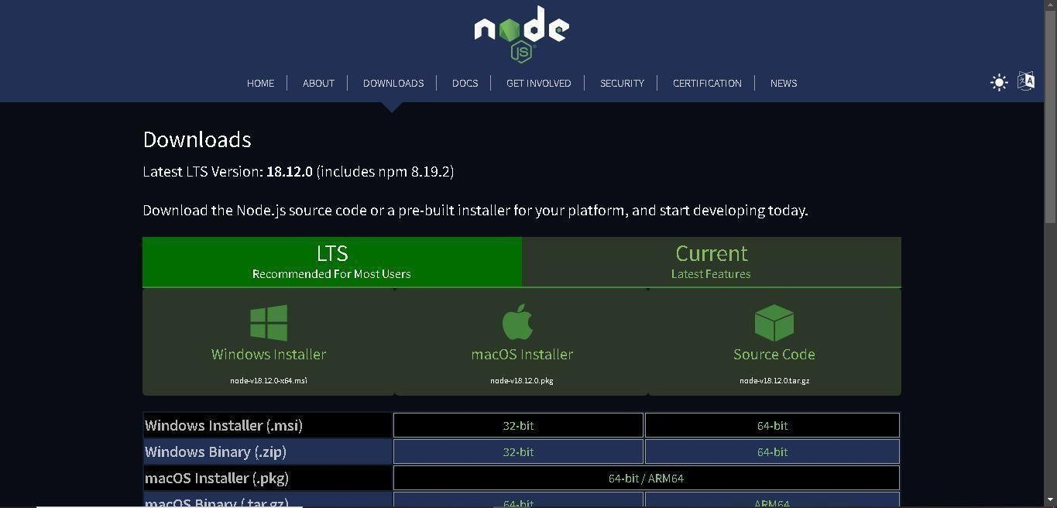

**STEP 2:** Setup node.js and configure command prompt for error check. Open node-red from the generated link.

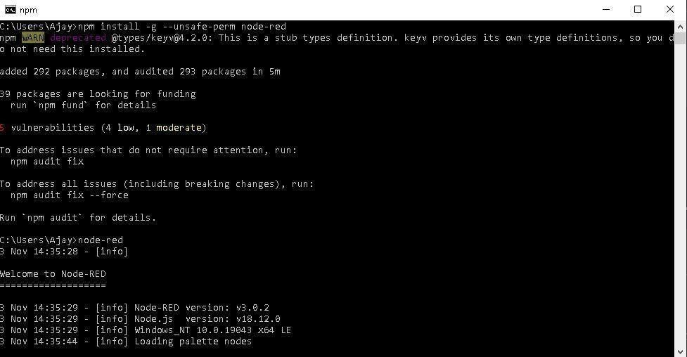

**STEP 3:** Generating API key and Authentication token.

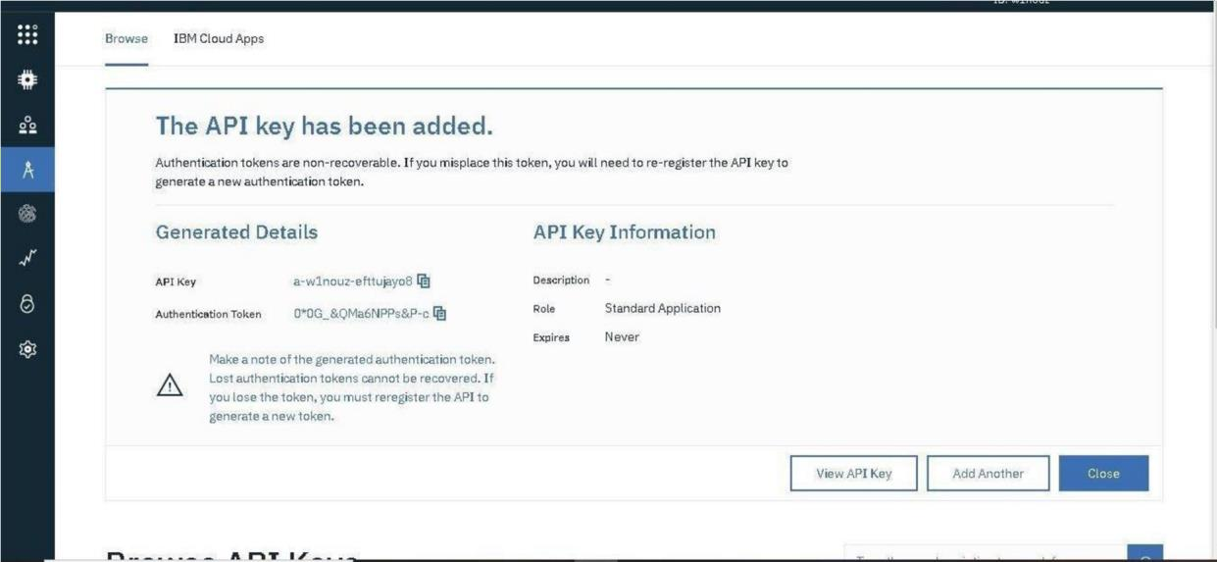

**STEP 4:** Edit Ibmiot in node.

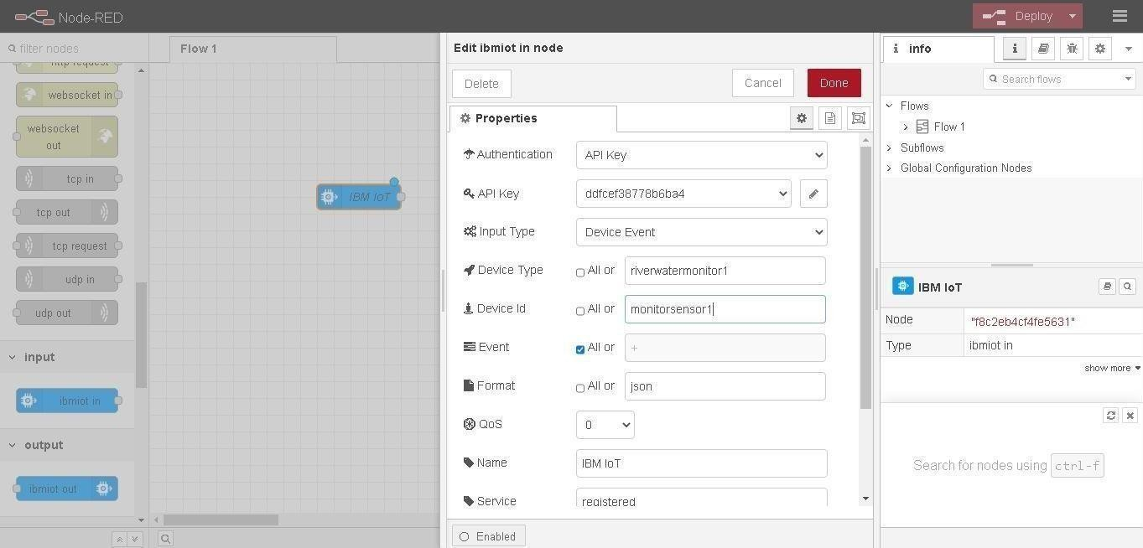

**STEP 5:** Connect Ibmiot in and debug 1 and deploy.

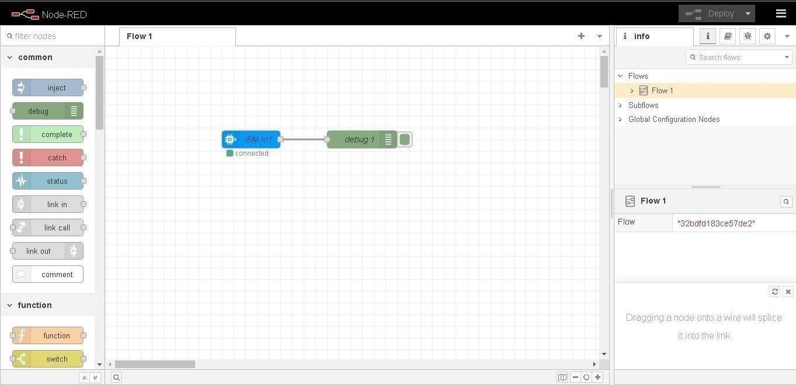

**STEP 6:** Edit gauge node (here the gauge nodes are named as Temperature, pH and Turbidity).

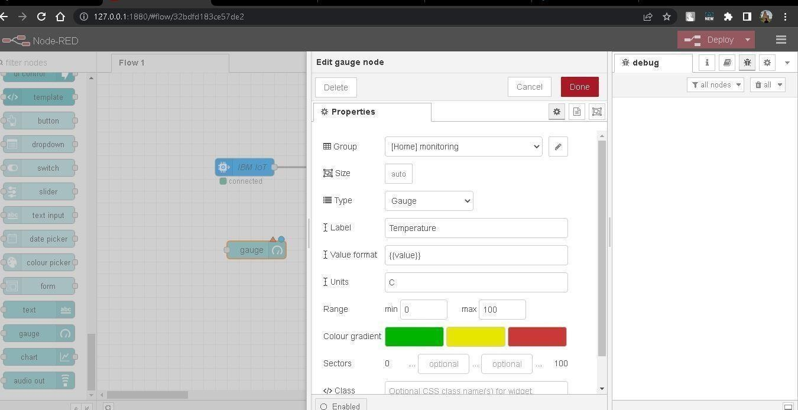

Fig 1

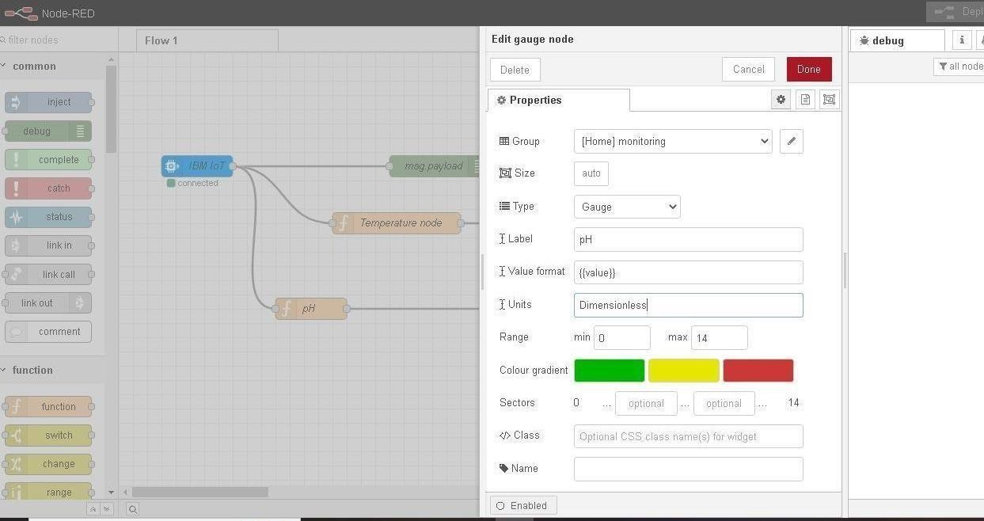

Fig 2

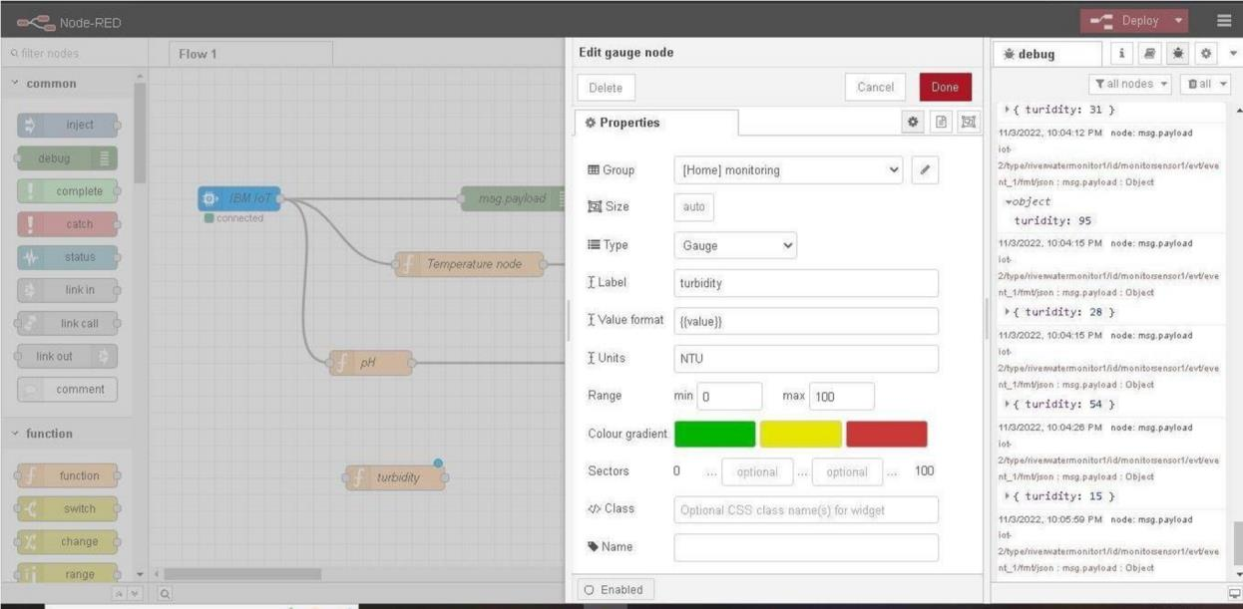

Fig 3

**STEP 7:** Simulated program to get the random values.

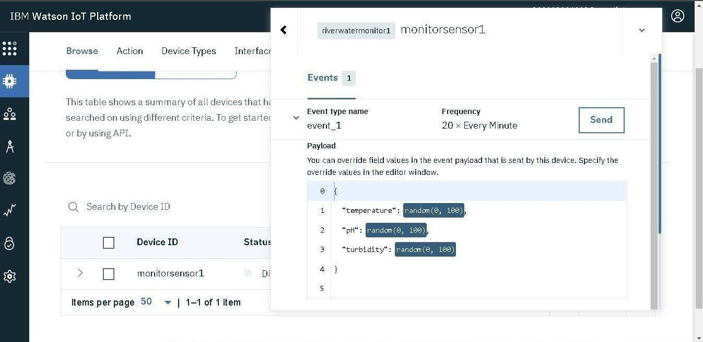

**STEP 8:** Generate debug message from IBM Watson IoT Platform and connect the nodes.

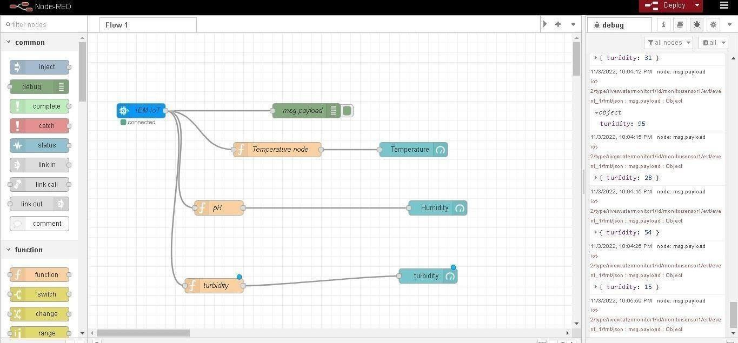

**STEP 9:** Edit button mode [light ON and light OFF].

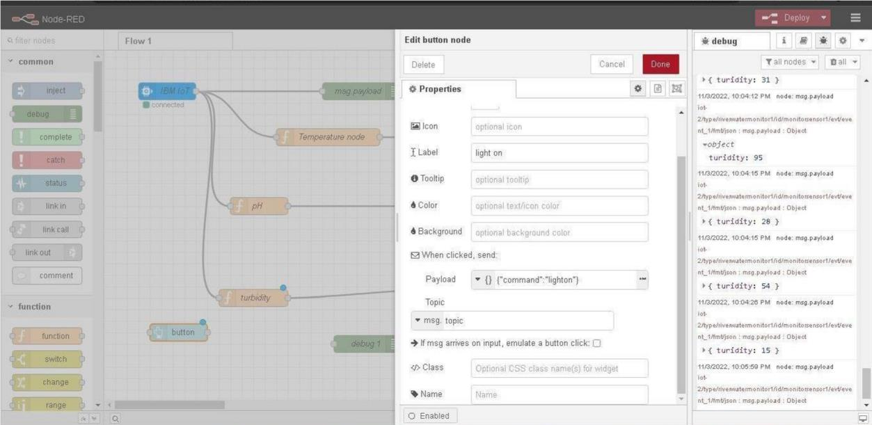

**STEP 10:** Entire flow diagram in Node-RED.

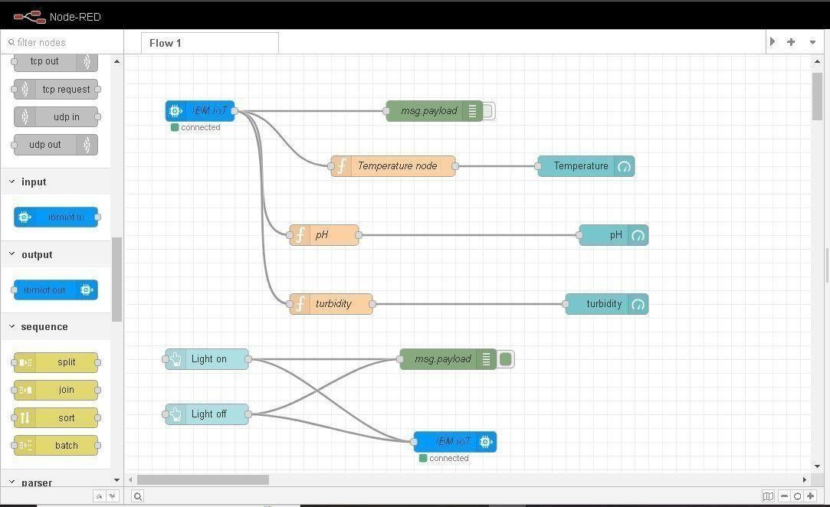

**STEP 11:** Generate the output from recent events.

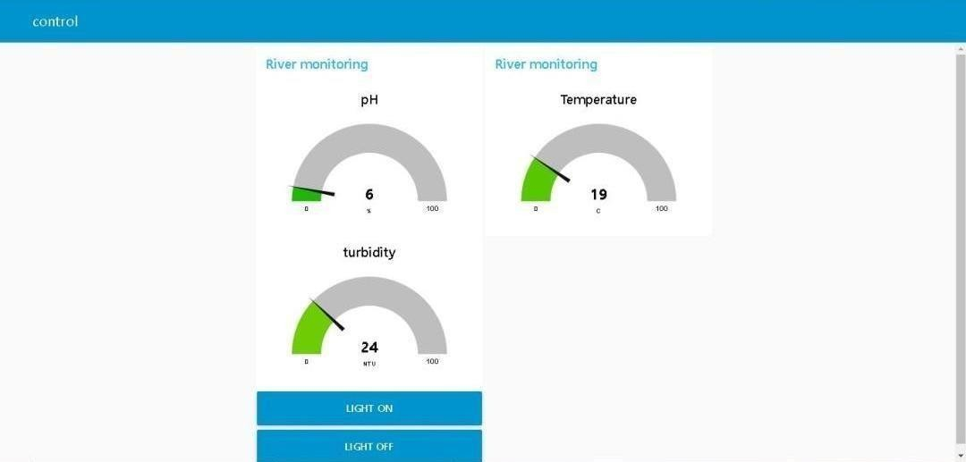

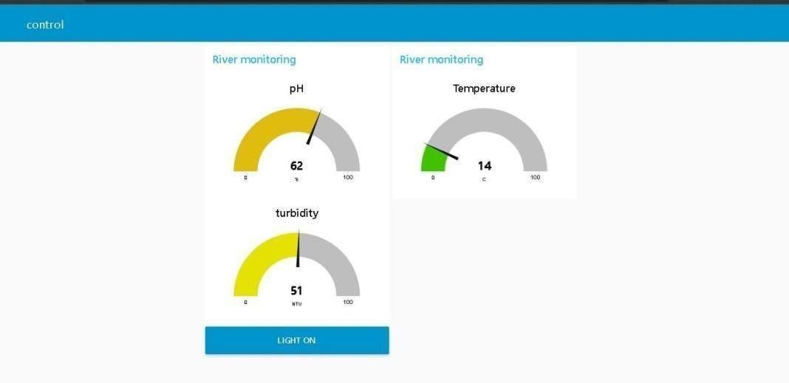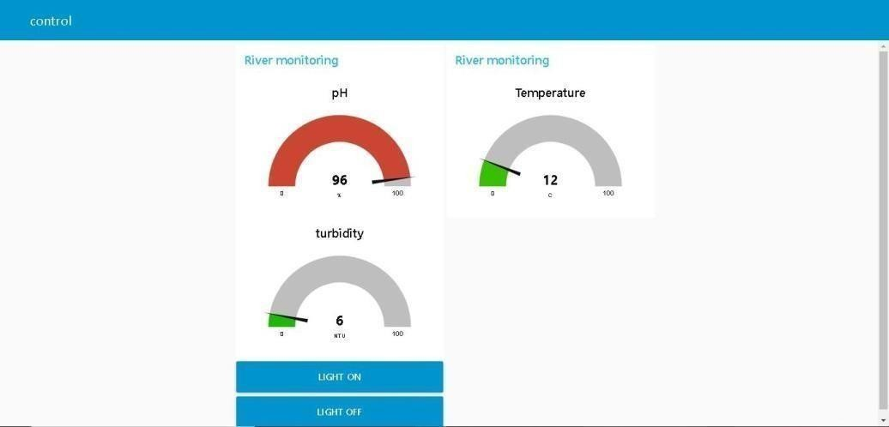

**STEP 12**: Implementing url in the function node to generate output.

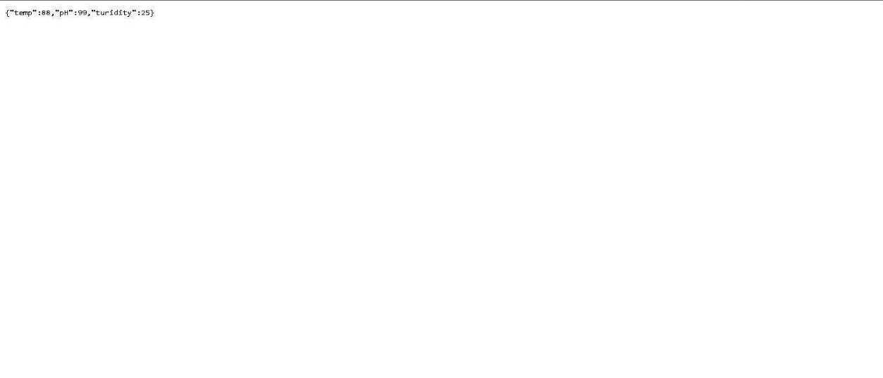

Step 13: MIT app inverter to design the app.

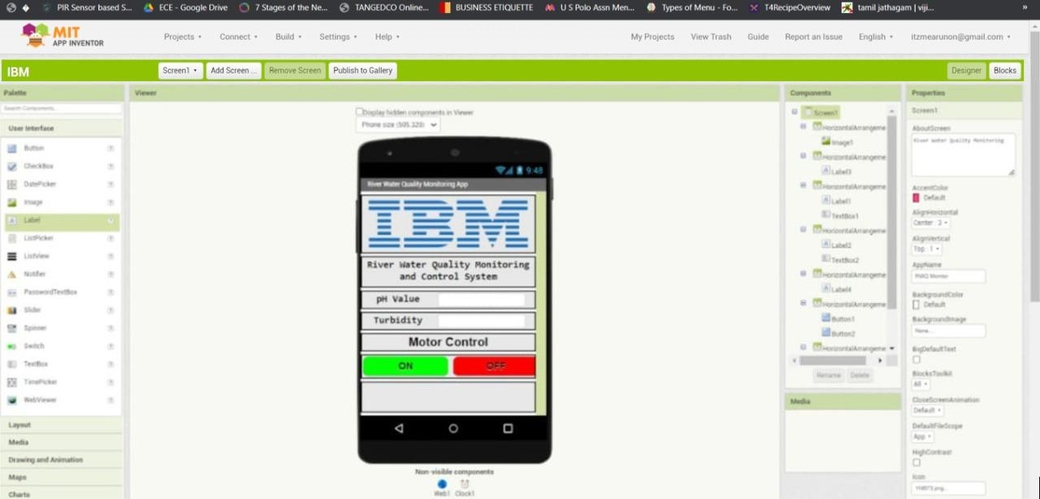

Fig 1

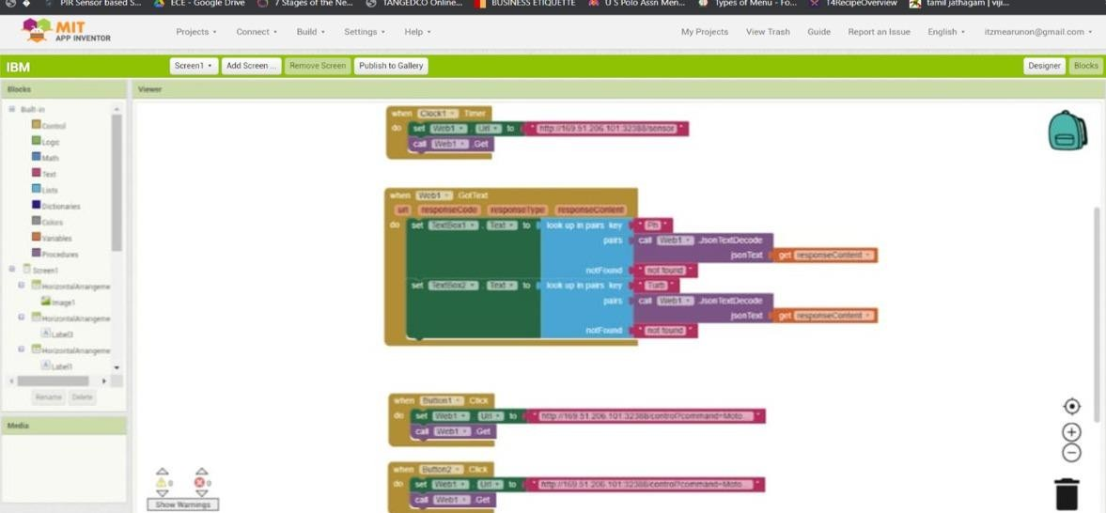

Fig 2

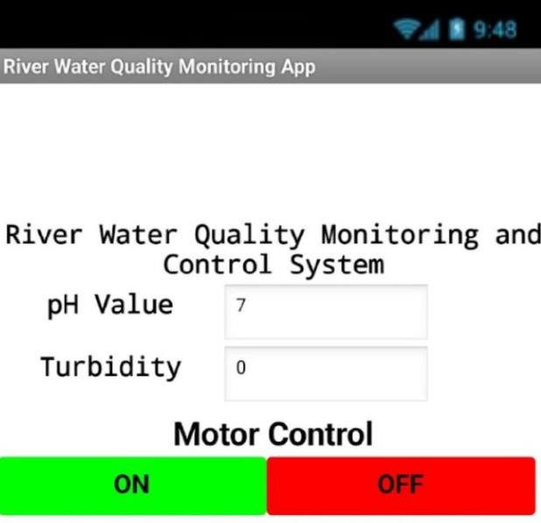

Fig 3